Student’s name | …………………………………………………….…… | Grade | 4
Subject | Computer | Week No. | 12
Lesson Title | Animation and Transition | Unit
Worksheet No. ( 12 )

Question A:
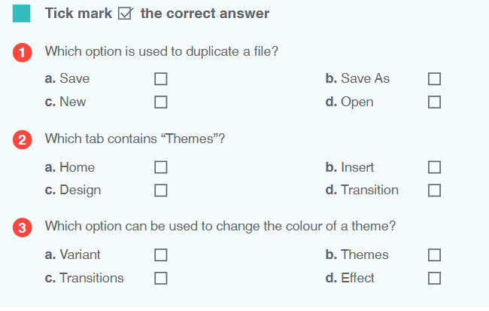

Good Luck

